FINAL YEAR MAJOR PROJECT

This report, in the form of a template, has been specifically designed for B.Tech. (CSE) students working on their Final Year Major Project (FYP) at Computer Science and Engineering Department, Krishna Engineering College, Ghaziabad.

Every group of students is required to do the following:

1. Complete all the sections of this template
2. Get it certified by the assigned internal advisor before the day of evaluation.
3. Submit 01 photocopy to each of the following, on or before the day of evaluation:
   1. Internal advisor
   2. Co-internal advisor (if any)
4. Submit original copy to FYP coordinator on the day of evaluation
5. Email PDF/MS Word document to technical advisors and FYP coordinator.

Note:

1. Use UK English
2. There should be NO grammatical or spelling mistakes
3. Submission after due date will not be accepted
4. For more information, contact your internal advisor and/or FYP coordinator

- Read the above carefully and attach this page at the end of your report before submission -

Template prepared by:

Dr. Rahul Rastogi (Associate professor)

Department of CSE- Krishna Engineering College, Ghaziabad 1

# 1. Project identification

|  |  |
| --- | --- |
| 1.1 Project title |  |
| 1.2 Group members  (List names along with university roll no. and roles defined for project) | Member Name and Roll No. Role   |  |  |  | | --- | --- | --- | | 1. |  |  | | 2. |  |  | | 3. |  |  | | 4. |  |  | |
| 1.3 Technical advisor(s)  (As officially assigned) | 1.3.1 Internal advisor:  Name:  Designation:  1.3.2 Co-internal advisor (if any):  Name:  Designation: |

## 1.4 CERTIFICATE

|  |  |
| --- | --- |
| “This is to certify that the final year project work until mid-year evaluation held on ___________________, titled as stated in Sec. 1.1, executed (as till date) by the students’ group mentioned in Sec. 1.2, has been found satisfactory and every section of this report is reflecting the same.” | (Signature of internal advisor  & date) |

Department of CSE- Krishna Engineering College, Ghaziabad 2

# 2. Project insights

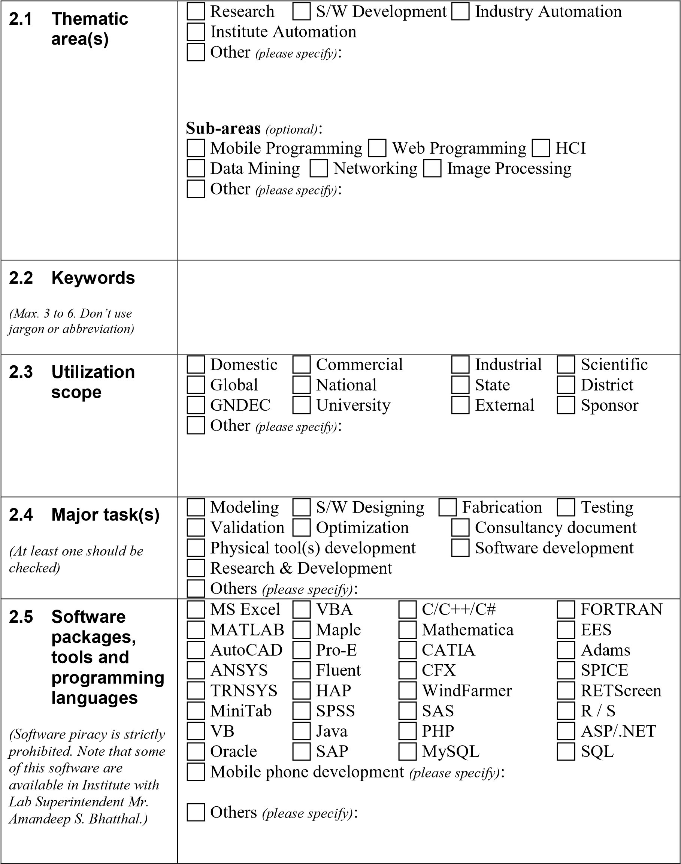

# 3. Relevant study material

|  |  |
| --- | --- |
| 3.1 Undergrad.  courses  (Must be from Information  Technology/ Computer  Science Engineering or other Applied Areas. Add more rows if required.) | Course code and title  1.  2.  3.  4.  5.  6. |
| 3.2 Books and  other printed material  (Must be easily accessible.  Add more rows if required.) | Reference # Title, edition, publishing year and    (if any) authors’ names  1.  2.  3.  4.  5.  6. |

|  |  |
| --- | --- |
| 3.3 Standards and databases  (Must be easily accessible.  Add more rows if required.) | Name, purpose, source and other details  1.  2.  3.  4. |
| 3.4 Online / web resources  (Must be easily accessible. Search engines, social blogs, and unauthentic resources should not be mentioned. Any reliable URL shortening service may be used. Add more rows if required.) | URL of specific web page  1.  2.  3.  4. |

# 4. Objective / Scope

|  |
| --- |
| Write the objective/scope that has been understood from project title and meetings with technical advisor(s) so far. Title and scope of project must be elaborated in detail. Maximum 500 words. |

1. Expected outputs

List expected outputs of the project in discrete terms. Maximum 250 words.

1. Utilization

Describe target beneficiaries, target market, potential customers, etc. Maximum 250 words.

# 7. Literature study / Data collection

|  |
| --- |
| Describe the topics and type of literature studied or collected for study, to define the project path and methodology. Citations are recommended. Maximum 500 words. |



Final Year Project – Progress Report

# 8. Methodology

Concisely list down the principle milestones and associated deliverables that must be achieved to accomplish the project objectives. Add more rows if required.

|  |  |  |  |  |
| --- | --- | --- | --- | --- |
| S.  No. | List of project milestones | Deliverable(s) | Expected number of days to complete | Percent Completed |
| 1. | Planning and Design | Project Plan, Wireframes, Mockups | 10 days | 80% |
| 2. | Front-end Development | HTML, CSS, JavaScript | 10 days | 70% |
| 3. | Back-end Development | PHP, MySQL | 10 days | 60% |
| 4. | Testing and Quality Assurance | Unit Tests, Integration Tests, Browser Testing | 10 days | 50% |
| 5. | Deployment and Launch | Website Deployment, Launch Strategy | 10 days | 70% |

# 9. Executed work

# **Planning and Design:**

# Project Plan: A detailed project plan might have been created, outlining the scope, objectives, timelines, and resource requirements for the project. This could include a Gantt chart or other project management tools.

# Wireframes: Wireframes are a low-fidelity representation of the layout and functionality of each page on the website. Executed work might include completed wireframes for each page or section of the website.

# Mockups: Mockups are a high-fidelity representation of the website's visual design and layout. Executed work might include completed mockups for each page or section of the website.

1. **Front-end Development:**

* HTML: Executed work could include completed HTML code for the website, including the header, footer, and main content sections for each page or section.
* CSS: Executed work could include completed CSS code for the website, including styling for fonts, colors, and layout.
* JavaScript: Executed work could include completed JavaScript code for the website, including any interactive features or animations.

1. **Back-end Development:**

* PHP: Executed work could include completed PHP code for the website's back-end, including database queries and server-side logic.
* MySQL: Executed work could include a completed MySQL database structure, including tables and fields for storing website data.

# Describe in detail the works along with the obtained results and deliverables that have been completed until now and how. Note that very general information about topics is NOT required so try to be specific. The sequence, as already described in Methodology (Sec. 8), should be followed as possible. Maximum 3 pages including equations, figures and tables etc.

**4 Testing and Quality Assurance:**

Unit Tests: Executed work could include completed unit tests for each feature or section of the website, ensuring that individual components are working as expected.

Integration Tests: Executed work could include completed integration tests for the website, ensuring that all components are working together seamlessly.

Browser Testing: Executed work could include completed browser testing, ensuring that the website works correctly on all major browsers and devices.

5. **Deployment and Launch:**

Website Deployment: E xecuted work could include a completed website deployment, including uploading website files to a web server and configuring the website's domain name.

Launch Strategy: Executed work could include a completed launch strategy, including marketing and promotion plans to generate traffic and increase visibility.

Overall, executed work refers to tangible deliverables that have been completed as part of the project. These deliverables could include completed code, design mockups, documentation, or other project artifacts, depending on the project's scope and requirements.

# 10. Remaining work

**Content Creation and Integration:**

* Content Creation: This involves creating and integrating the website's content, including text, images, and multimedia elements. The executed work might have already created a content plan and wireframes to guide content creation.
* Content Integration: The content will be integrated into the website's HTML and CSS, ensuring that it is displayed correctly across all devices and browsers.

**Testing and Quality Assurance:**

* User Acceptance Testing: This involves testing the website's functionality and usability with end-users to ensure that it meets their needs and expectations. Executed work might include creating test cases and scripts for user testing.
* Performance Testing: This involves testing the website's performance, including load times and responsiveness, to ensure that it can handle high traffic and usage.
* Security Testing: This involves testing the website's security measures, including authentication and data encryption, to ensure that user data is protected.

**Deployment and Launch:**

* Server Configuration: This involves configuring the web server and database for the website, ensuring that it is optimized for performance and security.
* Beta Testing: This involves testing the website in a live environment with a limited audience to ensure that it is stable and functional before a full launch.

To execute the remaining work, the following plans might be put in place:

* Content Creation Plan: This plan would outline the content creation process, including timelines, responsibilities, and quality assurance measures.
* User Acceptance Testing Plan: This plan would outline the user testing process, including recruiting participants, conducting tests, and analyzing results.
* Performance and Security Testing Plan: This plan would outline the testing process for website performance and security, including tools and metrics used to measure website performance and security.
* Server Configuration Plan: This plan would outline the server configuration process, including selecting a hosting provider, configuring the server environment, and testing server performance.
* Beta Testing Plan: This plan would outline the beta testing process, including selecting beta testers, setting up testing environments, and collecting feedback.
* Launch Strategy Plan: This plan would outline the launch strategy, including marketing and promotional activities, outreach to potential users, and post-launch evaluation metrics.

Overall, the plans to execute remaining work will involve following the established methodology and ensuring that all deliverables are completed according to the project plan and timeline. Effective communication and collaboration among team members will be essential to ensure that the project is executed successfully and meets the project objectives.

# 11. **References**

**Book:** Author(s). Book title. Edition. Place of publication: Publisher, year.

Example: G. Strang. Introduction to linear algebra. 4th ed. Belmont, CA: Wellesley-Cambridge Press, 2009.

**Journal Article:** Author(s). "Article title," Journal title, vol. number, no. issue, page range, month year.

Example: P. Jones, "The impact of climate change on water resources," Environmental Science & Technology, vol. 42, no. 10, pp. 3479-3488, May 2008.

**Conference Paper:** Author(s). "Paper title," in Proceedings of Conference Name, Place of Conference, Date of Conference, pp. page range.

Example: M. Chen, W. Wang, and S. Zhang, "A low-power data-driven FFT processor for OFDM applications," in Proceedings of IEEE International Conference on Communications, Beijing, China, May 2008, pp. 3307-3311.

**Online Resource:** Author(s) or Organization. "Webpage title," Name of Website, Date of publication or last update, URL.

Example: National Aeronautics and Space Administration. "NASA Launch Schedule," NASA, 2018, <https://www.nasa.gov/launchschedule/>.

**Database:** Name of Database. URL.

Example: PubMed. <https://pubmed.ncbi.nlm.nih.gov/>.

**Software Manual:** Name of Software. Version number. Publisher, year.

Example: MATLAB. Version 9.2. The MathWorks Inc., 2017.

**Figure:** Author/Creator/Title of Image. Year. Type of Image

12. Gantt chart

A detailed and neat Gantt chart should be attached separately after this page. Attached page may be landscape but it should not have any page number, header and footer. Gantt chart should be listing all the major and minor activities, indicating executed and remaining tasks, along with the time spans. Make sure that the Gantt chart is reflecting all the project milestones as described in Sec 8-10.

Final Year Project – Progress Report

# Evaluation by Technical Advisor(s) and Sponsor(s)

Please  if work is satisfactory or  if work is not satisfactory and therefore requires a revision.

|  |  |  |  |
| --- | --- | --- | --- |
| Section | Internal advisor | Remarks by Internal Advisor | Remarks by Project Coordinator(s) |
| 1. Project identification |  |  |  |
| 2. Project insights |  |  |  |
| 3. Relevant study material |  |  |  |
| 4. Objective/Scope |  |  |  |
| 5. Expected outputs |  |  |  |
| 6. Utilization |  |  |  |
| 7. Literature study/Data collection |  |  |  |
| 8. Methodology |  |  |  |
| 9. Executed work |  |  |  |
| 10. Remaining work |  |  |  |
| 11. References |  |  |  |
| 12. Gantt chart |  |  |  |
| Overall performance |  |  |  |

Department of CSE- Krishna Engineering College, Ghaziabad 17 Final Year Project – Progress Report

|  |  |  |  |
| --- | --- | --- | --- |
| Signature and date |  |  |  |

Department of CSE- Krishna Engineering College, Ghaziabad 17